**Project Report**

**on**

**Social Networking Website** **Leechi**

**Bachelor of Technology**

in

# Computer Science & Engineering



**Submitted To Submitted by**

Mrs. Kavita Rathi Rajeev Kumar

18001001044

Department of Computer Science & Engineering

# Deen Bandhu Chhoturam University of Science and Technology

**ACKNOWLEDGEMENT**

A successful task makes everyone happy. Success will often be crowned to people who made it reality but the people who are behind curtain with constant guidance and encouragement that made it possible will be crowned first on the eve of success. Words are inadequate to express my deep sense of gratitude towards all those people behind the screen who guided, inspired and helped me for the completion of our project work. The successful completion of the project on “SOCIAL NETWORKING” which I have undertaken has a partial fulfillment of the requirements for the award of Bachelor of technology degree in Computer Science and Engineering. It is with profound sense of gratitude that I acknowledge my project guide Mrs. Kavita Rathi for providing me with live specification and his valuable suggestion which encouraged me to complete this project successfully. I thank our Mrs. Kavita Rathi for permitting us to do this project. At last but not the least I thank entire Computer Science department who rendered their full cooperation for successful completion of the project.

(Rajeev Kumar)

**INDEX**

|  |  |  |
| --- | --- | --- |
| S. No. | Contents | Page no. |
| 1 | Introduction to the project | 1 |
| 2 | Objective and scope of the Project | 3 |
| 3 | Hardware and Software Requirement | 4 |
| 4 | Which Technology is Used and Why? | 6 |
| 5 | Technology used | 7 |
| 6 | Services Used | 9 |
| 7 | Library Used | 10 |
| 9 | Requirement analysis | 13 |
| 10 | Technologies Used | 16 |
| 12 | Deployment Services | 21 |
| 13 | Main Component & Features | 25 |
| 14 | Model & Schema | 29 |
| 15 | Snapshots | 32 |
| 15 | Conclusion | 48 |
| 16 | Refrences | 49 |

### Introduction

**SOCIAL NETWORKING** is a website which provides the up-to date information of all the students registered into it. It is effectively used for knowing the people of different groups. We can update our personal details. The user is also provided the facility of scraping to friends and to all the registered members from. They can wish their friends by sending E-Cards. technology for building applications for generating dynamic web content, such as **HTML,CSS, Reactjs,Saas,Material UI Lib,Node js**,etc.

A website succeeds-when it meets the needs of the people who use it, when it performs flawlessly over a long period of time, when it is easy to modify and even easier to use-it can and does change things for the better. But when software fails-when its users are dissatisfied, when it is error prone, when it is difficult to change and even harder to use-bad things can and do happen.

We all want to create websites that makes things better, avoiding the bad things that lurk in the shadow of failed efforts. To succeed we need discipline when software is designed and built. Many individuals and companies still develop software haphazardly, even as they build systems to service the most advanced technologies of the day. As a result, the quality of the software that we produce suffers and bad things happen.

This project report is intended to serve as a guide to the website developed on **Social Networking**. I have tried to follow the principles and rules as suggested by the software engineers as far as possible, in order to make this website a successful one. The report starts with a comprehensive introduction to the project undertaken as its very First Section. It includes objectives and scope of the project; about the front-end tool used i.e. React js with js and the Backend Node js Server. The second part presents and discusses the theoretical background of the project. The third section encompasses all the problems of the software that includes what is expected from the software, the demands and the requirements of the end-users. The fourth part is the System analysis and design section. This part focuses on requirements analysis and specification, analysis issues, detailed procedures and the database designs. In The fifth section, different approaches to formal evaluation and review techniques are explored. The sixth section highlights the methodology adopted for this project. The seventh part suggests the steps required to implement the software on the user machine. The eighth part discusses the hardware and software requirements of the user machines. The ninth part deals with the cost benefit analysis. The tenth section contains the data flow diagrams. The next section is the flowchart part. The next section is for the entity relationship diagram of the project. The thirteenth part explains the methodology used for testing. The fourteenth section is the test report. The fifteenth part is the most important part of the project i.e. the code for the software. The sixteenth part is the user manual section. The seventeenth part is the annexure for the topic that includes some details about the organization, the data dictionary, definitions, acronyms and abbreviations used in the report. The final section is the reference part that contains a list of the books and reports that were referred during the development of the project and the report as well.

The emphasis in this report is to document the important concepts and techniques used for the successful development of this project.

I do hope fervently that, through this report, the readers will get a real picture of what the project is all about. I also wish that may this website satisfies all the needs and requirements of the user.

#### 2. Objective and Scope of the Project

Social networks are important because they allow people to develop relationships with others with whom they might not otherwise be able to connect. It also helps boost business productivity when used for public relations, marketing, and advertising purpose.

**Some Purpose Are follow as- :**

1. **Linking Friends:** The primary objective of Leechi is to link the friends all over the world. Geographical distances shall not be a reason for cardiological distances between friends. They must stay in touch no matter where they are and what they are

And Leechi help this cause.

1. **Making new friends:** The next objective is to make new friends as per one’s own taste. Any social networking must not be limited to liking just existing friends. But

there must also be scope of making new friends having desired tastes.

1. **Security:** Security is a major issue. The next objective of Leechi is to keep website

free from fake accounts, hacks and other threats.

1. **Education:** Education through a social networking website is a big fun. Learning in a way you never get bored off, reaps big and tasty fruits. Leechi provide you this opportunity to learn new English language words, new facts and a lot more in a very innovative way.
2. **Fun:** The next objective is to introduce some fun element in the website. This can be accomplished by integrating some games and puzzles in the website. By doing so, Leechi will be the complete package for today’s generation.

Social media has changed the way we communicate today. It’s in our best interest to be informed about all of the new possibilities to manage our online reputation. The lines between professional and personal are blurring online and many times, we refer to our online presence as our “Personal Brand.” Your Personal Brand can be both the personal and professional “YOU.”

***Here are five benefits of using social media:***

##### ****1. Build relationships.****

Social media is not just about brands connecting with their customers. In fact, at its root, social media is about connecting people to people. If you’ve attended a Social Shift training session I’ve led, chances are you’ve heard that almost every single friend I have in San Francisco, I met through social media.

From a professional perspective, you can grow your professional network online tremendously by connecting with colleagues, mentors, role models and other professionals. If you nurture those relationships, you have a whole new network to tap when you’re looking for opportunities or professional guidance.

##### ****2. Share your expertise.****

Social media gives you an opportunity to talk about what you know and what you want to be known for. Sharing your expertise will attract potential professional and personal connections. Learn how to present your professional experience, achievements and results and you will get more and more opportunities to connect with like-minded people.

If you share content on topics that you know much about, you can begin to build credibility. This doesn’t only go for your online presence. If you live your personal brand and your actions reflect your online presence, it validates that you can be trusted and those relationships you are building will be that much more authentic and valuable.

##### ****3. Increase your visibility.****

If you spend time honing in on your expertise, consistently managing your social channels, then you have the potential to greatly increase your visibility and even become a thought-leader in your space. Good content gets shared, so if you are consistently posting quality content, the more people who share it, the more people see it.

It’s not just about pushing content, however. You also need to be engaging with other people’s content. Following people and interacting with them on social media will work to build relationships (we keep coming back to this one!) and will help to get your name out there for people to turn to.

##### ****4. Educate yourself.****

There is a lot of noise on the Internet. Social media allows you to hone in on what you really care about and what you really want to read. You can create lists that curate content from your favorite people, thought leaders in the space, or media outlets. You can easily learn about current events and things taking place near you.

##### ****5. Connect anytime****

I know to some of you this may sound like a disadvantage. But, the advantage of being able to communicate and connect with anyone instantly outweighs the potential negative.

Social media can help you connect before, during and after networking events, a conference or a meeting. People can get to know you prior to meeting you and be better equipped to talk in person. I know I’ve met people in person for the first time after following them online for a while and we felt like long lost friends!

1. Social media is a land of new opportunity. There are countless personal and professional benefits of using social media. With a little love and care, we can start to build and shape our personal brands into an epicenter of opportunity.

##### 3. Study and analysis of Existing System

**Existing System:** The existing system for Leechi is the current social networking giant-*The* *Facebook.*

**Study of Existing System:** *Facebook* is a social networking service launched in February 2004, owned and operated by Facebook It was founded by Mark Zuckerberg with his college roommates and fellow Harvard University students Eduardo Saverin, AzelAndrew McCollum, Dustin Moskovitz and Chris Hughes. The website's membership was initially limited by the founders to Harvard students, but was expanded to other colleges in the Boston area, the Ivy League, and gradually most universities in Canada and the United States, corporations, and by September 2006, to everyone of age 13 and older with a valid email

address.

**Current Stats:** The current presence of Facebook is all over the world. Facebook is ranked 2nd in the internet world next only to Google and have a record 1.15 billion active users till

March 2013. **Platform:** Facebook is developed using C++ and PHP. The database used by Facebook is MySQL. **Issues with Existing System:** The various issues with the existing

system are as follows:

1. *Compatibility of platform and database server:* The platform used to develop Facebook is PHP while database server used is MySQL. The compatibility between PHP and MySQL server is known to have certain issues when used with large data

regarding speed of operation.

1. *Low bit Hashing algorithm:* Facebook uses MD5 algorithm for encrypting passwords of the users. MD5 generates 128 bit hash values. 128 bit hash values is not enough to stop hash value collisions when you have more than 1.15 billion values in the database. Result is that the probability of having same hash value for two different words has increased which increased the chances of getting into ones account using

brute-force attack.

1. *Prone to brute force attack:* Facebook is more prone to brute force attack than other leading websites. The main reason for this is the hashing algorithm used for storing passwords and no captcha or similar support at log in.

**4. Proposed System**

The proposed system aims at overcoming the pitfalls of the existing system then replicating the major features of the same gradually. The major features of the proposed system are:

*SHA512 Algorithm:* The existing system uses 128 bit hashing algorithm which is not sufficient to minimize the probabilities of collisions. This can be eliminated by using 512 bit hashing algorithm in the proposed system.

* Map Feature With near By friends
* No Sql Database.

**Hardware Requirements:**

**For development:**

* 8 GB Ram
* 1.5 GHz processor or more
* Internet Connection (1Mbps broadband connection is recommended for smooth

operation).

**For Deployment:**

* 512 MB Ram
* Any processor with operating frequency not less than 1GHz.
* Internet connection (256Kbps broadband connection is recommended for smooth

operation).

**Software Requirements:**

**For development:**

* Visual Studio
* Chrome
* ColorZilla
* PostMan
* Git Lense
* Es6 Formatter
* Code prettier

**For Deployment**

* Github
* Heroku
* Aws
* GitBass
* Heroku watcher app

**Which Technology is Used and Why?**



**Technology used:**

* **Reactjs -** React. js is an open-source JavaScript library that is used for **building user interfaces specifically for single-page applications**. It's used for handling the view layer for web and mobile apps. React also allows us to create reusable UI components.
* **Nodejs -**  is an [open-source](https://en.wikipedia.org/wiki/Open-source_software), [cross-platform](https://en.wikipedia.org/wiki/Cross-platform), [back-end](https://en.wikipedia.org/wiki/Front_end_and_back_end) [JavaScript](https://en.wikipedia.org/wiki/JavaScript) [runtime environment](https://en.wikipedia.org/wiki/Runtime_system) that runs on the [V8 engine](https://en.wikipedia.org/wiki/V8_(JavaScript_engine)) and executes JavaScript code outside a [web browser](https://en.wikipedia.org/wiki/Web_browser). Node.js lets developers use JavaScript to write command line tools and for [server-side scripting](https://en.wikipedia.org/wiki/Server-side_scripting)—running scripts server-side to produce [dynamic web page](https://en.wikipedia.org/wiki/Dynamic_web_page) content before the page is sent to the user's web browser. Consequently, Node.js represents a "JavaScript everywhere" paradigm, unifying [web-application](https://en.wikipedia.org/wiki/Web_application) development around a single programming language, rather than different languages for server-side and client-side scripts.
* **Expressjs -** Express.js, or simply Express, is a back end web application framework for Node.js, released as free and open-source software under the MIT License. It is designed for building web applications and APIs. It has been called the de facto standard server framework for Node.js.
* **MongoDB -** MongoDB is a source-available cross-platform document-oriented database program. Classified as a NoSQL database program, MongoDB uses JSON-like documents with optional schemas. MongoDB is developed by MongoDB Inc. and licensed under the Server Side Public License.
* **HTML -** The HyperText Markup Language, or HTML is the standard markup language for documents designed to be displayed in a web browser. It can be assisted by technologies such as Cascading Style Sheets and scripting languages such as JavaScript
* **CSS -** Cascading Style Sheets is a style sheet language used for describing the presentation of a document written in a markup language such as HTML. CSS is a cornerstone technology of the World Wide Web, alongside HTML and JavaScript
* **SASS -** Sass is a preprocessor scripting language that is interpreted or compiled into Cascading Style Sheets. SassScript is the scripting language itself.
* **Redux -** Redux is an open-source JavaScript library for managing and centralizing application state. It is most commonly used with libraries such as React or Angular for building user interfaces. Similar to Facebook's Flux architecture, it was created by Dan Abramov and Andrew Clark.
* **SocketIO -** In most cases, the connection will be established with WebSocket, providing a low-overhead communication channel between the server and the client.

## ****Why choose of MERN Stack!****

1. **UI rendering and performance**

React JS is the best when it is about UI layer abstraction. Since React is only a library, it provides you the freedom to build the application and organize the code however you want. So, it is better than Angular in terms of UI rendering and performance.

**2. Cost-Effective**

As MERN Stack uses one language throughout that is Javascript so it will be beneficial for a company to hire Javascript experts only rather than hiring different specialists for different technology. This move will save a lot of time and money.

**3. Open Source**

All technologies that are involved in MERN are open-source. This feature allows a developer to get solutions to queries that may evolve during development, from the available open portals. As a result, it will be beneficial for a developer.

**4. Easy to switch between client and server**

As everything is written in one language this is why MERN is simple and fast. And also it is easy to switch between client and server.

**Service used :**

* **Mapbox** - a plugin for [Leaflet](https://docs.mapbox.com/help/glossary/leaflet/), is a JavaScript library that allows you to add an interactive map to your website. Mapbox.js is no longer in active development. Mapbox.js natively supports [raster tilesets](https://docs.mapbox.com/help/glossary/tileset/#raster-tilesets), and can support [vector tilesets](https://docs.mapbox.com/help/glossary/tileset/#vector-tilesets) using [L.mapbox.styleLayer](https://docs.mapbox.com/mapbox.js/api/v3.2.0/l-mapbox-stylelayer/)

.

* **EmojiPicker** – for emoji sending.
* **Weatherbit**- A weather Api.
* **Cloudinary** - a cloud-based image and video management services. It enables users to upload, store, manage, manipulate, and deliver images and video for websites and apps. [Wikipedia](https://en.wikipedia.org/wiki/Cloudinary)

**LIBRARY USED**

**At FrontEnd:**

* "react-awesome-slider": "^4.1.0",
* "react-cropper": "^1.3.0",
* "react-dnd": "^10.0.2",
* "react-dom": "^16.12.0",
* "react-helmet": "^6.1.0",
* "react-hook-form": "^4.9.8",
* "react-html-parser": "^2.0.2",
* "react-image-lightbox": "^5.1.1",
* "react-infinite-scroll-component": "^5.0.4",
* "react-infinite-scroller": "^1.2.4",
* "react-linkify": "^1.0.0-alpha",
* "react-loader-spinner": "^4.0.0",
* "react-map-gl": "^5.3.10",
* "react-places-autocomplete": "^7.2.1",
* "react-redux": "^7.2.0",
* "react-reveal": "^1.2.2",
* "react-router-dom": "^5.1.2",
* "react-scripts": "^4.0.3",
* "react-select": "^3.1.0",
* "react-slick": "^0.28.1",
* "react-toastify": "^8.1.0",
* "react-transition-group": "^4.3.0",
* "react-video-thumbnail": "^0.1.3",
* "reactjs-file-uploader": "^1.0.8",
* "redux": "^4.0.5",
* "redux-thunk": "^2.3.0",
* "simple-react-video-thumbnail": "^0.0.7",
* "socket.io-client": "^2.3.0",
* "styled-components": "^5.3.3",
* "sun-time": "^1.0.2",
* "validator": "^12.2.0",

**At BackEnd**

* "bcryptjs": "^2.4.3",
* "body-parser": "^1.19.0",
* "cloudinary": "^1.21.0",
* "cors": "^2.8.5",
* "dotenv": "^8.2.0",
* "express": "^4.17.1",
* "express-validator": "^6.4.0",
* "jimp": "^0.9.3",
* "jsonwebtoken": "^8.5.1",
* "mongoose": "^5.7.8",
* "mongoose-unique-validator": "^2.0.3",
* "multer": "^1.4.2",
* "multer-storage-cloudinary": "^2.2.1",
* "nodemon": "^2.0.2",
* "socket.io": "^2.3.0"

**For Deployment Services**

** **

** **

**Features Of Social Media**

**Main Components:**

* Register
* Friends
* Chat
* Near By
* Weather
* Notification
* Account
* Setting

**user features:**

* register and login users.
* post images can be uploaded using camera or file system.
* pagination on every pages.
* Dark mode.
* Weather option
* Near by friends
* search other users by username.
* user suggestions menu.
* save any post to collection.
* Emoji picker.
* delete posts and comments.
* admin panel is included.
* Explore page to view other posts by random users.
* notifications page.
* profile page.
* edit profile page user data.
* password is stored in database in encrypted format with salt.
* create and edit posts.
* like ,comment, share and edit posts.
* posts include text(caption) and image(s).
* comment on posts.
* reply comments.
* like commets.
* clear notification option.
* profile page shows user details and posts with following and followers menu.
* Group chat
* Single chat
* Online friends
* Video feed
* Share location
* Edit image
* Upload profile
* Lazy loading
* Send image to other user while chat
* Chat with socket io

**Admin features:**

* admin panel shows total number of post ,users,reported posts etc.
* admin can see posts reported by more than specified number of users.
* Admin can see users all post
* Admin can delete post or video
* Admin can delete user
* Admin can delete chat group

**Model or Schema**

**Importat Schema**

**User Schema**

const userSchema = Schema({

    name:{

        type:String,

        required:true

    },

    email:{

        type:String,

        required:true,

        unique:true,

    },

    chatRooms: [userChatRoomSchema],

    password:{

        type:String,

        required:true,

        minlength:6

    },

    username:{

        type:String,

        required:true,

        unique:true

    },

    cover:{

        type:String

    },

     isOnline: {

      type: Boolean,

      default: false,

    },

    socketId: {

      type: String,

      default: '',

    },

    img:{

        type:String,

        default:"image "

    },

    publicId:{

        type:String

    },

    about:{

        livesIn:{

            type:String

        },

        bio:{

            type:String,

            maxLength:255

        },

        birth:{

            type:String

        },

        gender:{

            type:String

        },

        from:{

            type:String

        }

    },

    posts:[{ type: mongoose.Types.ObjectId, required: true, ref: 'Post' }],

    notifications:[{type:mongoose.Types.ObjectId,ref:'Notification'}],

    friends:[{type:mongoose.Types.ObjectId,ref:"User"}],

    unReadNotifications:{

        type:Number,

        default:0

    }

},{

    timestamps: true

})

USE CASE DIAGRAM

MODEL DFD

SCREENSHOT

**Module 2:**  Module 2 deals with creating basic classes in C#. Classes related to providing Captcha Support, sending emails, SHA512 Hashing Algorithm were created. Use of controls for providing Captcha are avoided since most of these are prone to captcha readers.

**Module 3:** Module 3 deals with user registration, email verification, editing profile, uploading profile picture, resetting password, troubleshooting for forgotten password, maintaining user log. For user registration and verification of genuine users, captcha support and email verification is used. Passwords are stored as SHA512 Hash values in Hexadecimal format for security purposes. Details related to registration are stored in registration table. User Log is maintained by storing login time, logout time, session ID, IP address, location in the userlog table.

**Module 4:** Module 4 deals with searching friends, sending/accepting/denying friend requests, removing existing friends and open chat. Searching of friends can be done by using the first or last name of the registered user. Registered and verified user is allowed to send friend requests to other users and even block certain persons. The user is also allowed to accept or reject a friend’s request and remove anyone from his/her friend list. Another option of open chat is provided in this module. In open chat any user can chat with all other users.

**Module 5:** Module 5 deals with Private chat, uploading images in albums, and updating status with provision of posting comments.

**Module 6:** Module 6 deals with writing testimonials, deleting account, Integrating Flash games, word of the day, thought of the day, jokes and other related things

**Module 7:** Module 7 is related to testing of the website. Unit testing is done after development of each component of the website. For system testing, different test cases are developed and project is tested as per these cases.

##### 6. Problem Definition

**Problem Statement**:

* Leechi is an online social network service by which user can establish a network among the people residing in all over the world. All the information can be easily accessed and shared among the people.
* This system provides users to register their various types of profile like social, personal, general, professional. Send a message, upload the photos so that user can maintain own album & many more.

**Need of the System**:

This website is developed keeping in mind the above-mentioned problems. The needs and requirements of the end users are also kept in mind while designing this website. This website will enable its users to maintain their friend list and user can update their friend list as well as we want to establish a network among the people residing in all over the world.

All the information can be easily accessed and shared among the people.

Thus, **Leechi** is developed in order to facilitate it users to establish network between one to many persons and maintain all people’s profile. It also helps them to save their time and energy when they want to share some kind of information, views, ideas etc. to their group friend’s without spending so much time for communicating to each other. Leechi provides social communisms so that people can interact each other even both of them so far away from each other.

##### 7. Benefits to the User

Websites have become a driving force. It is the engine that drives business decision-making. It serves as the basis for modern scientific investigations and engineering problems solving. It is a key factor that differentiates modern products and services. It is embedded in systems of all kinds: transportation, medical, telecommunication, military, industrial processes, entertainment, office products . . . the list is almost endless. Website is virtually inescapable in a modern world. And as we move into the twenty-first century, it will become the driver for new advances in everything from elementary education to genetic engineering. This website designed to help users social meet new friends and maintain existing relationships. The main goal of the service is to make your social life and that of your friends, more active and stimulating. Conclusively this website will provide following benefits to its users:

* Users can establish a network among the people residing in all over the world. All the information can be easily accessed and shared among the people.

* Makes information retrieval & sharing ideas & thought quicker and easier. User can maintain messages that have been sent to and received from others.

* Users can send invitation to another friend to join the friend list and also remove the existing ones.

* Shows Jokes, word of the day, this day in history and lot more which is automatically updated.

* Saves time and energy in searching the details of a particular using strong search engine.

* Protects the information from unauthorized users by implementing role based security.

##### 8. Feasibility Study

**Feasibility Analysis:** Feasibility study is done so that an ill-conceived system is recognized early in definition phase. During system engineering, however, we concentrate our attention on four primary areas of interest. This phase is really important as before starting with the real work of building the system it was very important to find out whether the idea thought is possible or not.

1. **Economic Feasibility:** An evaluation of development cost weighted against the ultimate income or benefit derived from the developed system.
2. **Technical Feasibility**: A study of function, performance and constraints that may affect the ability to achieve an acceptable system.
3. **Operational Feasibility:** A study about the operational aspects of the system.

###### Economic Analysis-

Among the most important information contained in feasibility study is Cost Benefit Analysis and assessment of the economic justification for a computer based system project. Cost Benefit Analysis delineates costs for the project development and weighs them against tangible and intangible benefits of a system. Cost Benefits Analysis is complicated by the criteria that vary with the characteristics of the system to be developed, the relative size of the project.

Expected return on investment desired as part of company’s strategic plan. In addition, many benefits derived from a computer-based system are intangible (e.g. better design quality through iterative optimization, increased customer satisfaction through programmable control etc.)

As this is an in-house project for the company, to be used for its own convenience and also it is not that big a project. So neither it requires a huge amount of money nor any costly tools or infrastructure need to be set up for it.

###### Technical Analysis-

During technical analysis, the technical merits of the system are studied and at the same time collecting additional information about performance, reliability, maintainability and predictability.

Technical analysis begins with an assessment of the technical viability of the proposed system.

1) What technologies are required to accomplished system function and performance? 2) What new materials, methods, algorithms or processes are required and what is their development risk?

3) How will these obtained from technical analysis form the basis for another?

Go/no goes decision on the test system? If the technical risk is severe, if models indicate that the desired function cannot be achieved, if the pieces just won’t fit together smoothly-it’s back to the drawing board.

As the website is very much economically feasible, then it is really important for it to be technically sound. After analysing all the proposed modules, The system is found to be technically feasible

**Operational Feasibility-**

The project is operationally feasible. So because of the above stated advantages the users of the system will not be reluctant at all.

**Legal Feasibility-**

It determines the proposed system conflicts with legal requirements; system will comply with the local Data Protection Acts. The proposed system is legally feasible.

##### 9. Requirement Analysis

Requirements specification is the starting step for the development activities. During requirement specifications, the goal is to produce a document of the client’s requirements.

This document forms the basis of development and software validation. In the SRS (Software Requirement Specification), Three parties are involved-the client, end users and software developer. The requirements document has to be such that the client and user can understand it easily and the developer can use it as a basis for software development.

The SRS is a document that completely describes what the proposed system should do without describing how the software will do. The basic goal of the requirements face is to produce the SRS, which describe the complete external behaviour of the proposed software.

**Need of SRS:**

An SRS document specifies:

* The required of the system in terms of input data, required processing, output data, operational scenarios and interfaces.
* The attribute of a system including performance, security, maintainability, reliability, audit ability, availability and safety requirements and design constraints.
* A SRS is helps the clients in understanding their needs.
* SRS establishes the bases for agreement between client and the supplier on what the software product will do.
* A high quality SRS is a prerequisite to high quality software.
* A high quality reduces the development cost.

**SCOPE of SRS:**

The scope of SRS document is valid until the end of the project. Because, it is the basic for all the phases. Only on the basis of SRS, whole project is developed. This is the only document that describes the requirement of the system. It is meant for used by the developer and will be the basic for validating the final delivered system. Any change made to the requirement in the future will have to go through a formal change process.

**SRS for Leechi:**

* **User friendly:** The system development should be user friendly understandable and easy to use so that native user can easily learn to use the system.
* **Response and processing time:** Response & processing time for various

attributes should be less so that user can immediately get the desired results.

* **Maximum throughput:** The system produce maximum throughput with maximum input.
* **Flexibility:** The system must be flexible in nature so that likely changes & alteration can be easily made.
* **Robustness:** System should be able to handle any undesired situation and errors encountered at various levels. It must give response to errors, in a clear precise & lucid fashion.
* **Accuracy:** The degree of accuracy should be high otherwise the utility of the entire system will be rendered useless.
* **Cost element:** It is a prominent quantitative measure of the performance of the system. Certainly a good system requires less memory to serve a given demand.

System must be provide tangible & intangible cost saving.

* **Information security:** Records in the system must be safe, confidential under the system control. The different users are given different access to right to control database so that no leakage of vital data to outsiders or to those who can miss-utilize this information.
* **User’s satisfaction:** System should be able to satisfy the user’s requirements.

This is the main and conspicuous measure of the system performance. The system must raise the morale of the users. The higher the morale, the greater the expected work performance level. Moreover, system should reliable, versatile & efficient.

##### 10. Technologies Used

**Front End:**

###### 1. .NET Framework

The Microsoft .NET Framework is a software technology that is available with several Microsoft Windows Operating systems. It includes a large library of pre-coded solutions to common programming problems and a virtual machine that manages the execution of programs written specifically for the framework. The .NET framework is a key Microsoft offering and is intended to be used by most new applications created for the Windows platform.

The pre-coded solutions that form the framework’s Base Class Library cover a large range of programming needs in a number of areas, including user interfaces, data access, database connectivity, cryptography, web application development, numeric algorithms and network communications. The class library is used by programmers, who combine it with their own code to produce applications.

Programs written for the .NET Framework execute in a software environment that manages the program’s runtime requirements. Also part of the .NET Framework, this runtime environment is known as the Common language Runtime (CLR). The CLR provides the appearance of an application virtual machine so that programmers need not consider the capabilities of the specific CPU that will execute the program. The CLR also provides other important services such as security, memory management and exception handling. The class library and the CLR together compose the .NET Framework.

**Interoperability:**

Because interaction between new and older applications is commonly required, the .NET Framework provides means to access functionality that is implemented in programs that execute outside the .NET environment. Access to COM components is provided in the System.Runtime.InteropServices and System Enterprise Services namespaces of the framework; access to other functionality is provided using the P/Invoke feature.

**Common Runtime Engine**

The Common Language Runtime (CLR) is the virtual machine component of the .NET framework. All.NET programs execute under the supervision of the CLR, guaranteeing certain properties and behaviours in the areas of memory management, security and exception handling.

**Base Class Library**

The Base Class Library (BCL), part of the Framework Class Library (FCL), is a library of functionality available to all languages using the .NET Framework. The BCL provides classes which encapsulate a number of common functions including file reading and writing, graphic rendering, database interaction and XML document manipulation.

**Simplified Deployment**

Installation of computer software must be carefully managed to ensure that it does not interface with previously installed software, and it combines to security requirements. The .NET framework includes design features and tools that help address these requirements.

**Security**

The design is meant to address some of the vulnerabilities, such as buffer overflows, that have been exploited by malicious software. Additionally, .NET provides a common security model for all applications

**Portability**

The design of the .NET Framework allows it to theoretically be platform agnostic, and thus cross-platform compatible. That is, a program written to use the framework should run without change on any type of system for which the framework is implemented. Microsoft’s commercial implementations of the framework cover Windows, Windows CE and the Xbox 360. In addition, Microsoft submits the specifications for the Common Language Infrastructure (which includes the core class libraries, Common Type System and the Common Intermediate Language) the c# language, and the C++/CLI language to both ECMA and the ISO, making them available as open standards. This makes it possible for third parties to create compatible implementations of the framework and its languages on other platforms.

**2. ASP.NET:**

ASP.NET is a web and windows application framework marketed by Microsoft that programmers can use to build dynamic web sites, web applications, window applications and XML web services. It is part of Microsoft’s .NET platform and is the successor to Microsoft’s Active Server Pages (ASP) technology. Asp.NET is built on the Common Language Runtime, meaning programmers can write ASP.NET code using any Microsoft

.NET language.

**Back-End:**

**1. ADO.NET:** ADO.NET is a set of computer software components that can be used by

programmers to access data and data services. It is a part of the base class library that is included with the Microsoft .NET Framework. It is commonly used by programmers to

access and modify data stored in relational database systems, though it can also be used to

access data in non-relational sources.

ADO.NET consists of two primary parts:

• Data Provider • Data Sets.

##### 11. System Planning

**Introduction:** Software project managers take the overall responsibility of steering a project to success. This surely is a very hazy job description. But, it is very difficult to objectively describe the job responsibilities of a project manager.

**Work breakdown structure**

Work breakdown structure is used to decompose a given task set recursively into small activities. WBS provides a notation for representing the major tasks needed to be carried out in order to solve a problem. The root of the tree is labelled by the problem name. Each node of the tree is broken down into smaller activities that are made the children of the node. Each activity is recursively decomposed into smaller sub-activities until at the leaf level; the activities require approx. two weeks to develop. If a task is broken down into a large number of very small activities, these can be distributed to a large number of engineers. If the activity ordering permits, the solutions to these can be carried out independently. Thus, it becomes possible to develop the product faster.

The following figure represents the WBS of website:

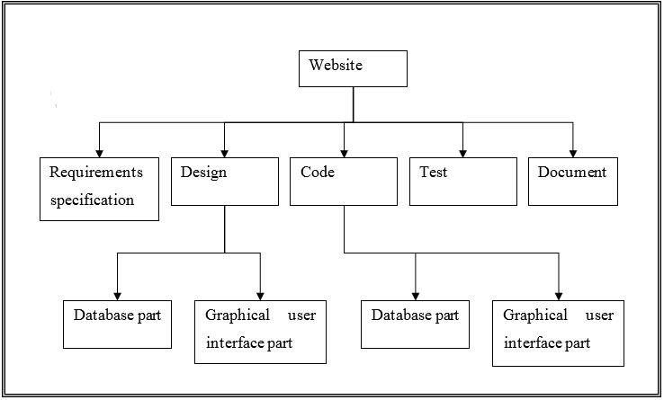

Fig-11.1 Work Breakdown Structure of Website

###### PERT CHART

PERT shows precedence relationships among the tasks and various stages of a project. By the helps of PERT chart, a project manager can identify the activities and the amount of time they require, show their interrelationships, specify their sequence, and have a meant of monitoring progress on the project. PERT makes use of tasks. Like milestone charts, it shows achievements. These achievements however are not task achievements. They are terminal achievements, called EVENTS.

**Each activity/Task of the project is represented by a directional are (more commonly known as arrow) pointing in the direction of progress in this project.**

The circles represent the beginning or completion of a task. The nodes at the network (also referred as events) establish the relationship among the different activities of the project. The rules are available for construction networks:

1. Each activity is represented by one and only one arrow in the network.
2. Each action must be identifying by two distinct nodes.

This is the table of ‘Activity’ and its estimated time duration, which are used to accomplish the project “LEECHI.

|  |  |  |
| --- | --- | --- |
| Activity | Preprocessor(s) | Duration (In Days) |
| A: Database Design | - | 1 |
| B: Module 1 | A | 4 |
| C: Module 2 | B | 7 |
| D: Module 3 | C | 7 |
| E: Module 4 | D | 7 |
| F: Module 5 | E | 7 |
| G : Module 6 | F | 7 |
| H: Module 7 | G | 7 |
| I: Documentation | H | 10 |

Table 11.1-Activity Table

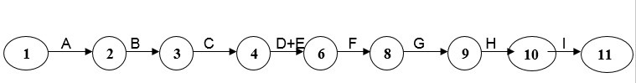

Fig 11.2-PERT chart

##### 12. Methodology Used

A software life cycle is the series of identifiable stages that a Software product undergoes during its lifetime. The first stage in the life Cycle of any software product is usually the feasibility study stage. The Subsequent stages are: requirement analysis and specification, design, coding, testing and maintenance. Each of these stages is called a life cycle Phase. A life cycle model represents all the activities required to make a software product transit through its life cycle phases. It also captures the order in which these activities are to be undertaken. The most strict life cycle model used is the Classical Life Cycle Model. However, in any practical software development work, it is not possible to strictly follow the classical waterfall model from every phase to its preceding phases.

**Methodology adopted:**

**Incremental Model:** The incremental build model is a method of software development where the model is designed, implemented and tested incrementally (a little more is added each time) until the product is finished. It involves both development and maintenance. The product is defined as finished when it satisfies all of its requirements. This model combines the elements of the waterfall model with the iterative philosophy of prototyping.

The product is decomposed into a number of components, each of which are designed and built separately (termed as builds). Each component is delivered to the client when it is complete. This allows partial utilization of product and avoids a long development time. It also creates a large initial capital outlay with the subsequent long wait avoided. This model of development also helps ease the traumatic effect of introducing completely new system all at once.

There are some problems with this model. One is that each new build must be integrated with previous builds and any existing systems. The task of decomposing product into builds is not trivial either. If there are few builds and each build degenerates this turns into Build-AndFix model. However if there are too many builds then there is little added utility from each build.

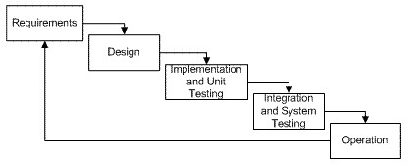

Fig 12.1-Incremental Model

###### Stage 1: Investigation Phase

Whether you design a small program to add two numbers or you are into developing a software system for the automation of an entire airline company, this is the first stage which can never be overridden. Unless you know what you are going to design, you cannot approach the problem.

Here, the specifications of the output or the final product are studied and marked. If the software that is going to be designed should not contain certain features, for reasons like security, then it is also mentioned in this stage.

###### Stage 2: Analysis Phase

With all the requirements and constraints in hand, a final view of how the product should exactly be, is decided. The exact way in which the software should function is mentioned in this stage.

###### Stage 3: Design Phase

Well, here the actual work begins. Every type of resource which will be required for the smooth designing of the software is mentioned here in this phase. What type of database will be required, what type of data should be supported, etc. are some of the important aspects that are decided in this phase. Data structures, software architecture, interface representations, algorithmic details.

###### Stage 4: Implementation and Testing Phase

Now starts the coding part. Here, the software is designed as per the algorithm. Hence it becomes very important that the algorithm should be properly designed. The software designed as per the algorithm needs to go through constant software testing and error correction processes to find out if there are any flaw or errors.

###### Stage 5: Installation and Testing Phase

Here the various codes designed by different programmers are integrated together and is tested if the software works as per the specifications provided. The setup of the final software which needs to be installed at the clients system is also designed and tested so that the client does not face any problem during the installation of the software. The product is then handed over to the client.

###### Stage 6: Maintenance Phase

The work of software development does not end with the handing of the software to the client. The software designers may have to constantly provide support to the client to resolve any of the Issues which may arise.

###### Characteristics

1. Combine elements of linear and parallel process flow.
2. Incremental process flows applied sequence in a staggered fashion as calendar time progresses.
3. Decomposed into a number of components, each of which are designed and built separately.

**Strengths**

1. Focus on the delivery of an operational product with each increment.
2. Provide clients flexibility in making their decision.
3. Customer’s confidence is high as they validate every increment and provide feedback **Weaknesses**
4. Needs good planning and design.
5. Needs a clear and complete definition of the complete system before it can be broken down and built incrementally.
6. Integration needs are very high.

##### 13. System Design

“System analysis” describes what a system should do to meet the info needs of user while

“System design” specifies how the system will accomplish the objective. This is the most creative and challenging phase of system development life cycle. The term “Design” describes a final system and process by which it is developed. It refers to the technical specifications that will be applied in implementation.

The primary objective of the system design is to deliver the requirement exactly as specified by the user for a particular report and design said to be a failure

**Data flow diagram:**

Fig 13.1- DFD(1)



User



Registration



Authorization



And



Verification



Registered



A



B



C



D



Registration



User Log



E



Fig 13.2- DFD(2)



A



Sending/Accepting/denying/



Blocking friend requests



Registration



Friend List



B



Uploading status and



Posting Comments



Registration



Status



Status Comments



Fig 13.3- DFD(3)



C



Uploading Pictures



and posting



Registration



Images



Image



Comments



Fig 13.4- DFD(4)



D



Uploading notes and



books



Registration



Notes and books



Fig 13.5- DFD(5)



E



Writing



Testimonials



Registration



Friend List



Testimonials



Fig 13.6- DFD(6)

**ER Diagram:**

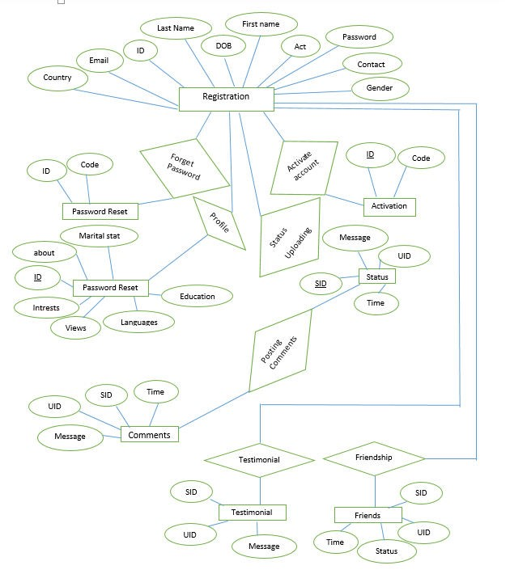

Fig 13.7- ER Diagram

##### 14. Testing

**Testing Methodology:** ➢ Test plan has been created to guide the overall testing process.

* Modular testing has been used to test each module.

* Black box testing has been used to test the functionality of each module.

* ASP.Net debugger has been used as a tool to black box test functional behaviour of module.

* ASP.Net debugger has also been used for white box testing by comparing step-bystep execution against white box cases.

* On-line testing of the software by live entering the details of five different users.

###### T ES T C A S E -1

TEST NO. : 1

TEST TYPE : Unit Testing

INPUT : Password

OBJECTIVE : Checking Password Security

EXPECTED OUTPUT: Access to Authorized Users Only

ACTUAL OUTPUT : Password Security Successful

RESULT : Access to Only Authorized Users

###### T E S T C A S E -2

TEST NO. : 2

TEST TYPE : UNIT TESTING

INPUT : Unverified Email during Login

OBJECTIVE : Validating User

EXPECTED OUTPUT: Ask for Verification Code

ACTUAL OUTPUT : Verification Successful

RESULT : Access Only to Verified Users

###### T E S T C A S E -3

TEST NO. : 3

TEST TYPE UNIT TESTING

INPUT : Password during Registration.

OBJECTIVE : Password must contain at least one lower case, one upper case and one numeric

EXPECTED OUTPUT : ERROR MESSAGE

ACTUAL OUTPUT : ERROR MESSAGE

RESULT : Password must contain at least one lower case, one upper case and one numeric

###### T E S T C A S E -4

TEST NO. : 4

TEST TYPE UNIT TESTING

INPUT : Checking data of non-friend member

OBJECTIVE : A user must not see data of another user who is not in friend list

EXPECTED OUTPUT : No Data must be visible except basic Information

ACTUAL OUTPUT : No data is visible except basic Information

RESULT : No data other than Basic information is available until the user accepts friend’s request

##### 15. Snapshots

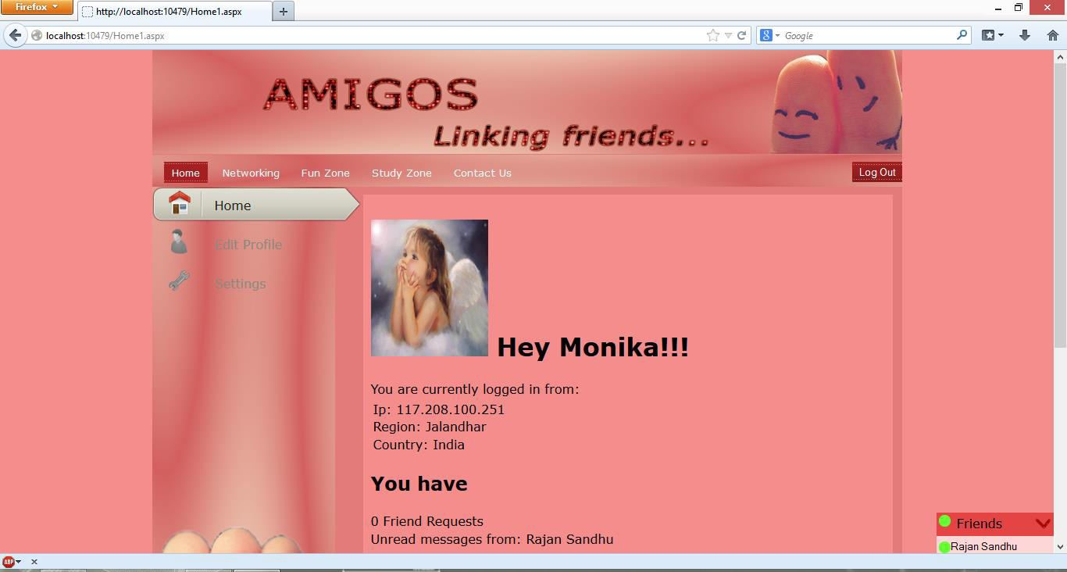

Figure 15.1: Home Screen (Home Tab)

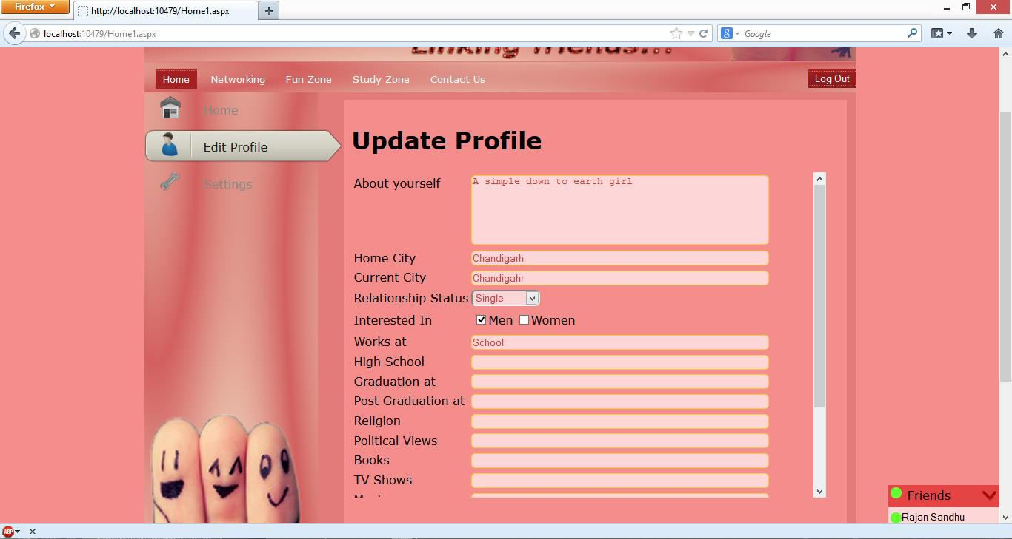

Figure 15.2: Home Screen (Profile Tab)

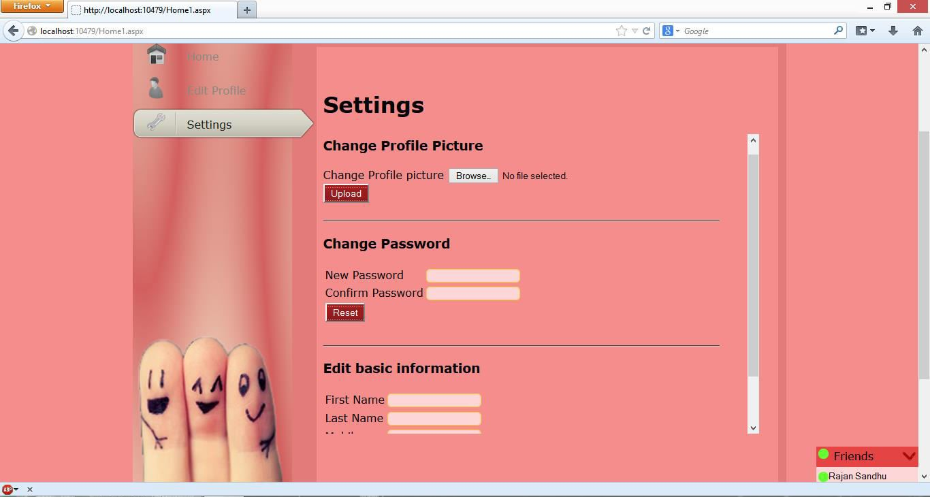

Figure 15.3: Home Screen (Settings Tab)

Figure 15.4: Networking Page (Posts Tab)

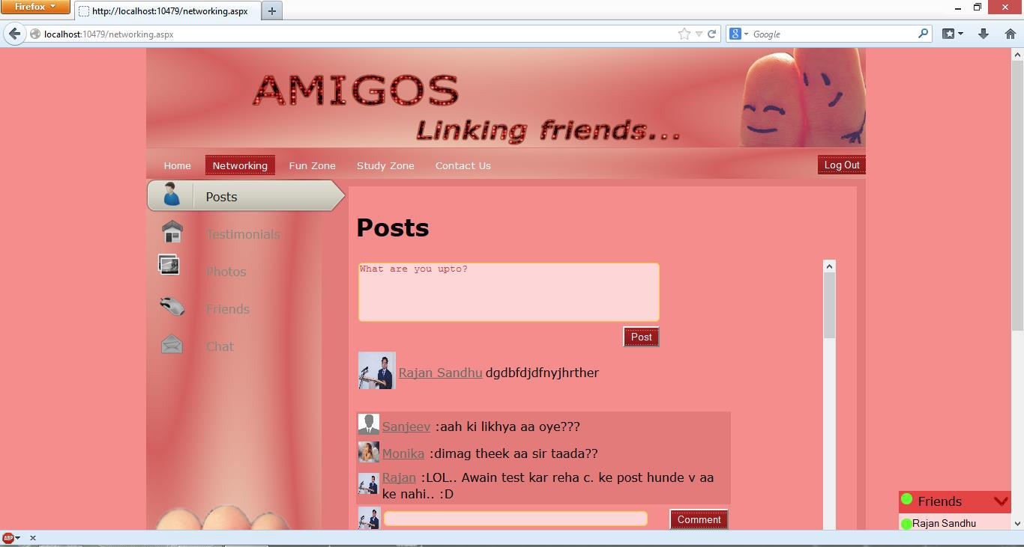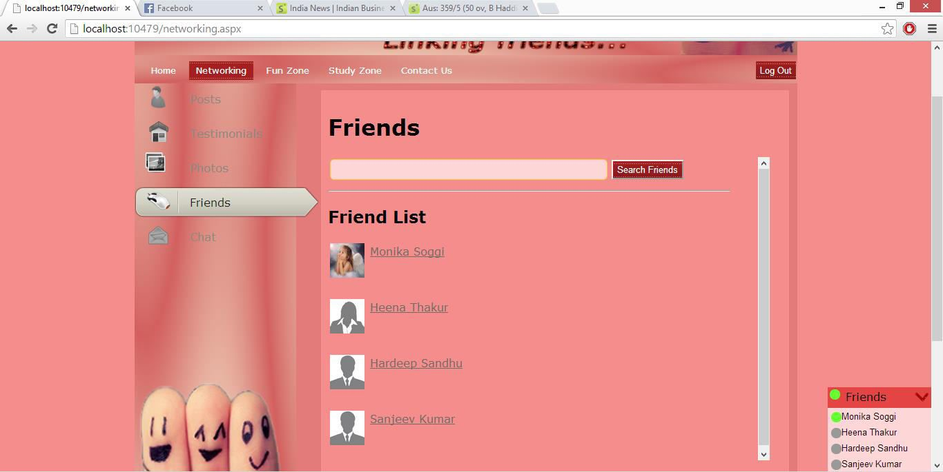

Figure 15.5: Networking Page (Friends Tab)

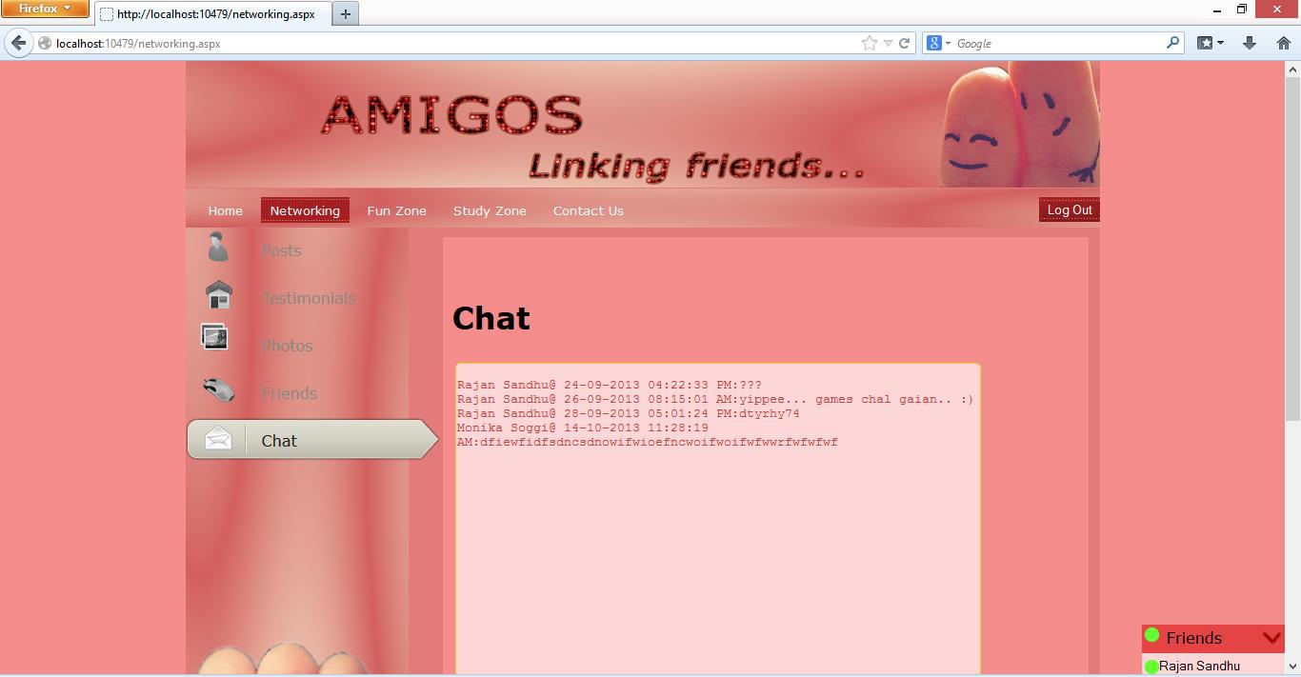

Figure 15.6: Networking Page (Chat Tab)

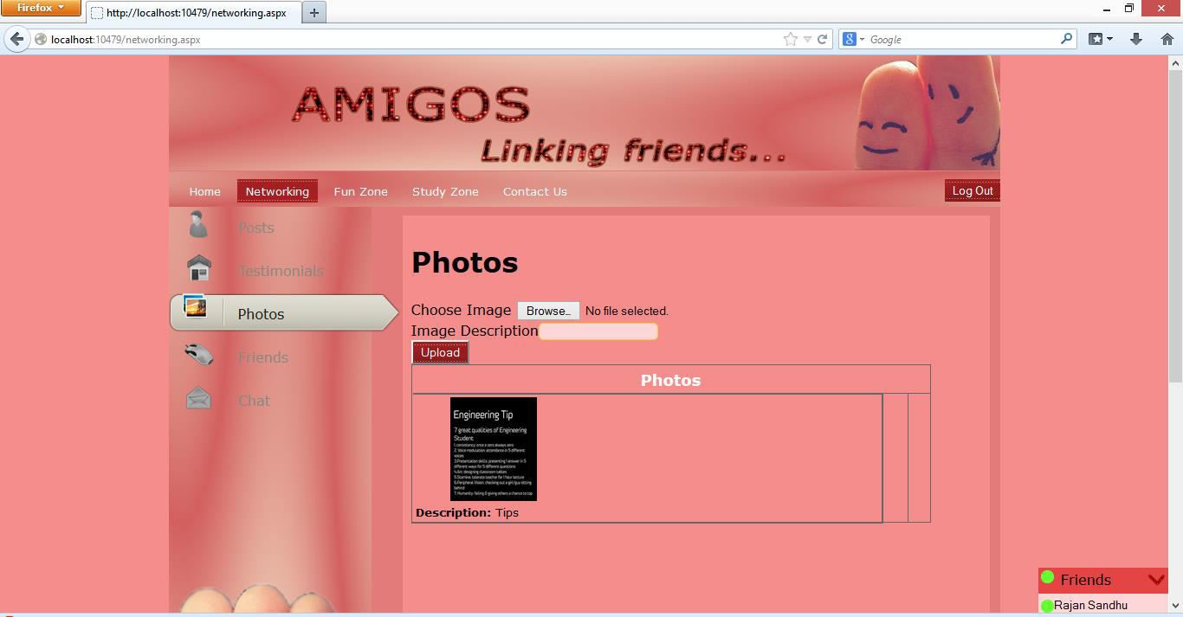

Figure 15.7: Networking Page (Photos Tab)

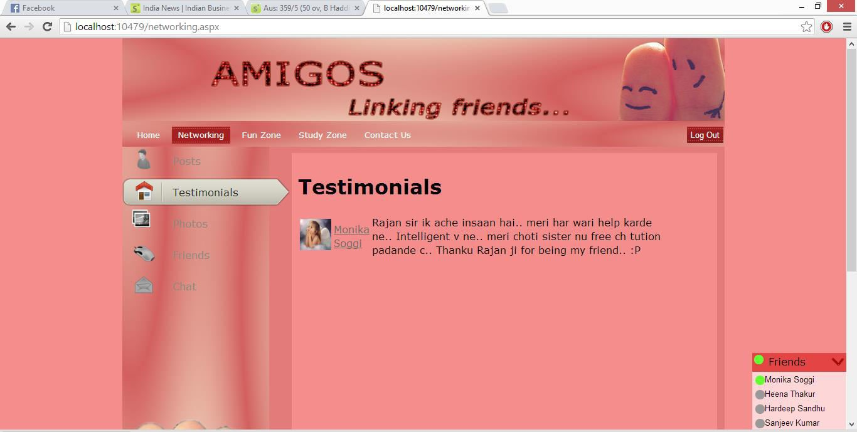

Figure 15.8: Networking Page (Testimonials Tab)

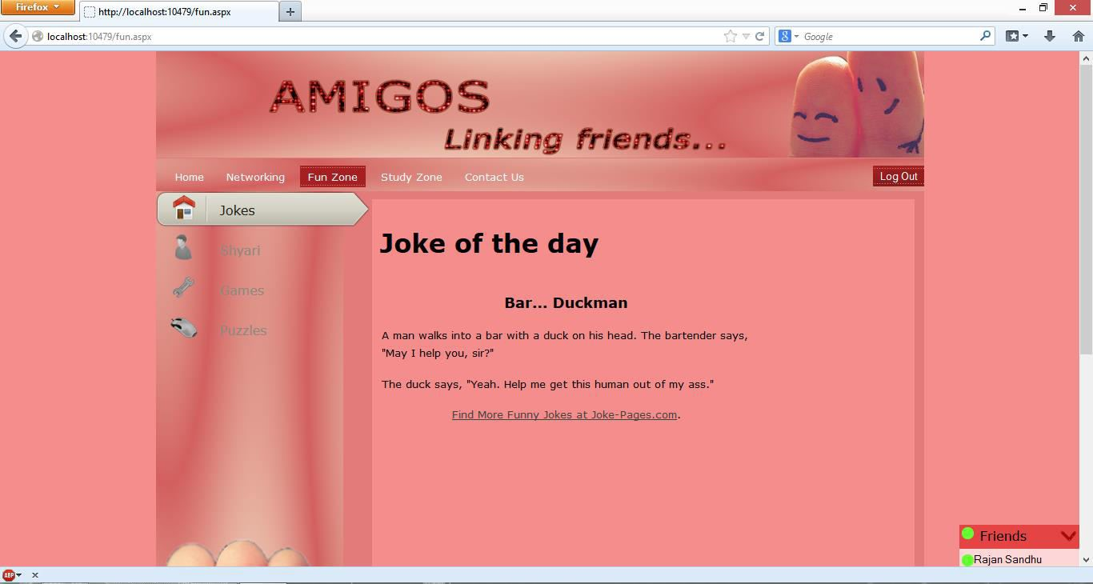

Figure 15.9: Fun Zone Page (Joke of the day Tab)

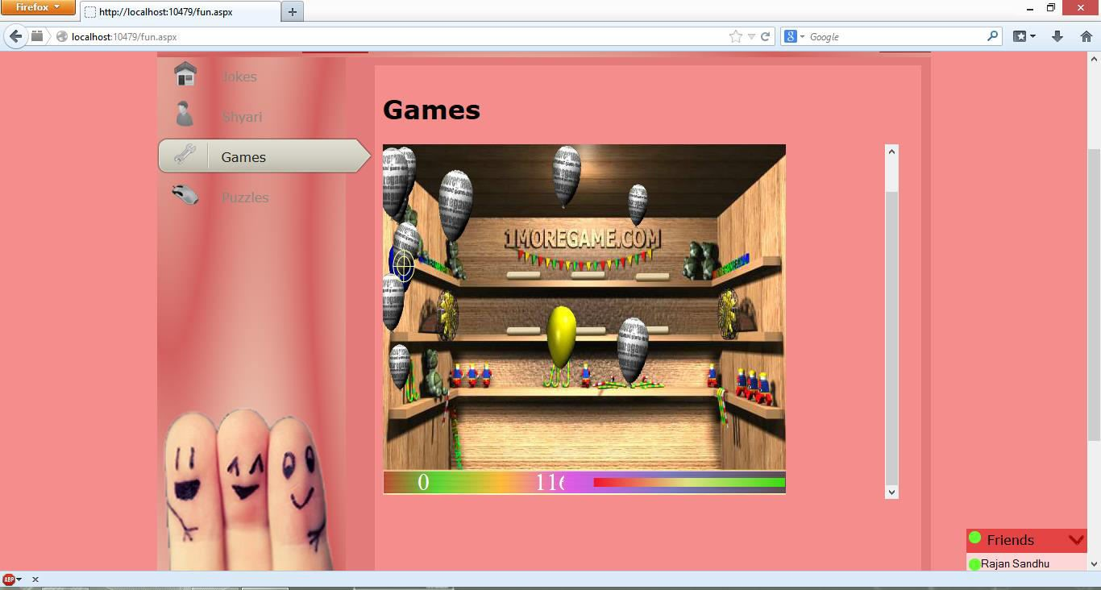

Figure15.10: Fun Zone Page (Games Tab)

Figure 15.11: Fun Zone Page (Puzzle Tab)

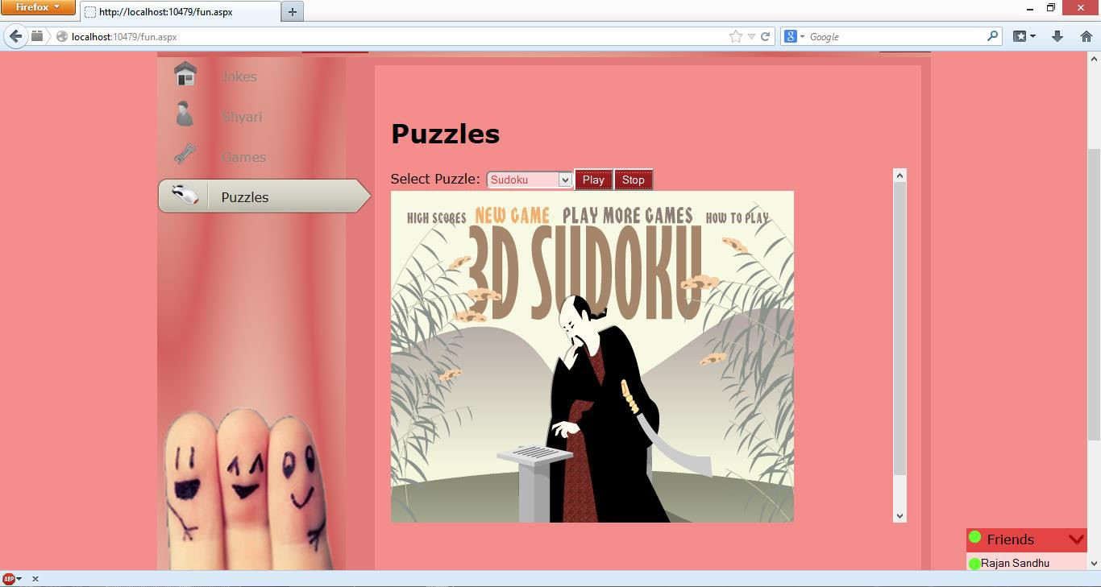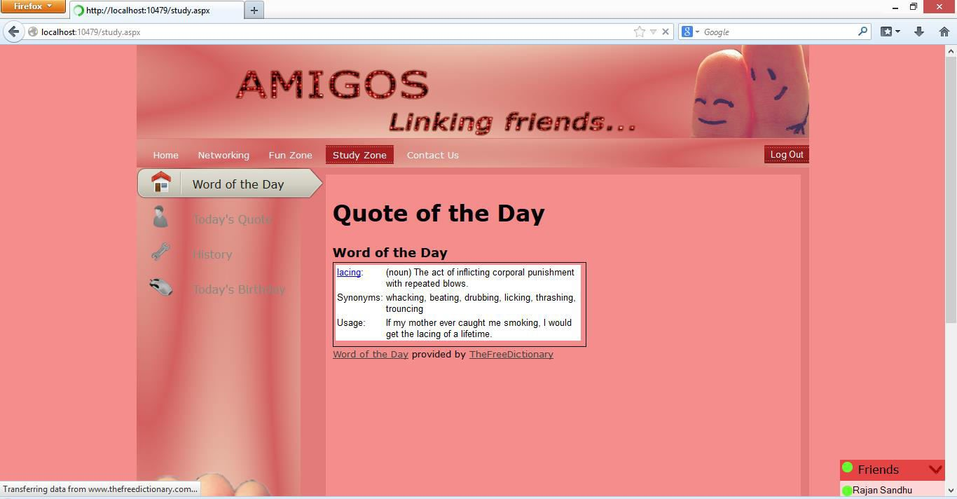

Figure 15.12: Study Zone Page (Word of the day Tab)

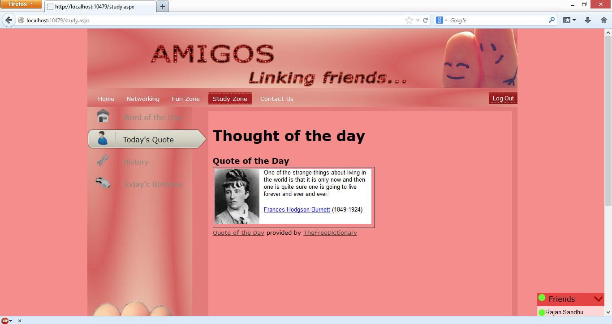

Figure 15.13: Study Zone Page (Thought of the day Tab)

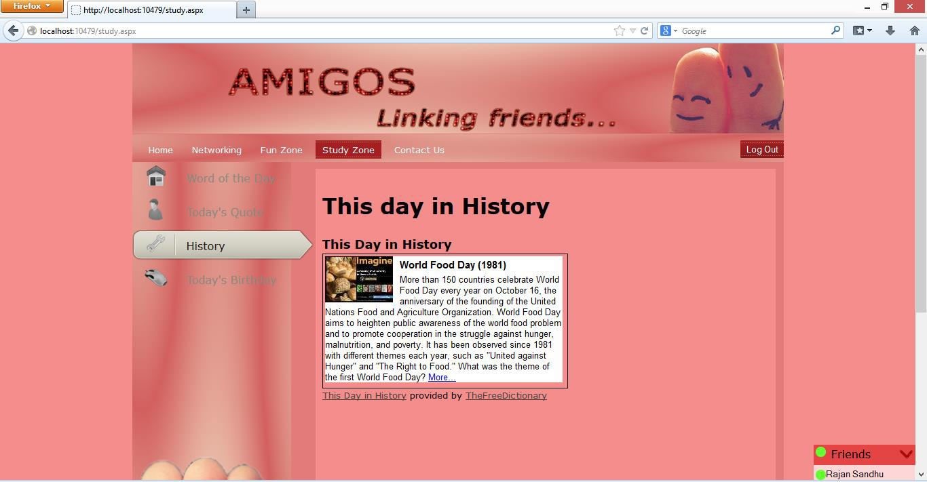

Figure 15.14: Study Zone Page (History Tab)

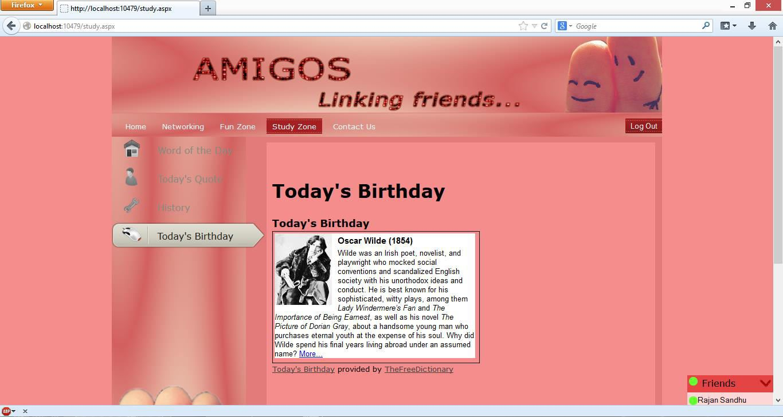

Figure 15.15: Study Zone Page (Today’s Birthday Tab)

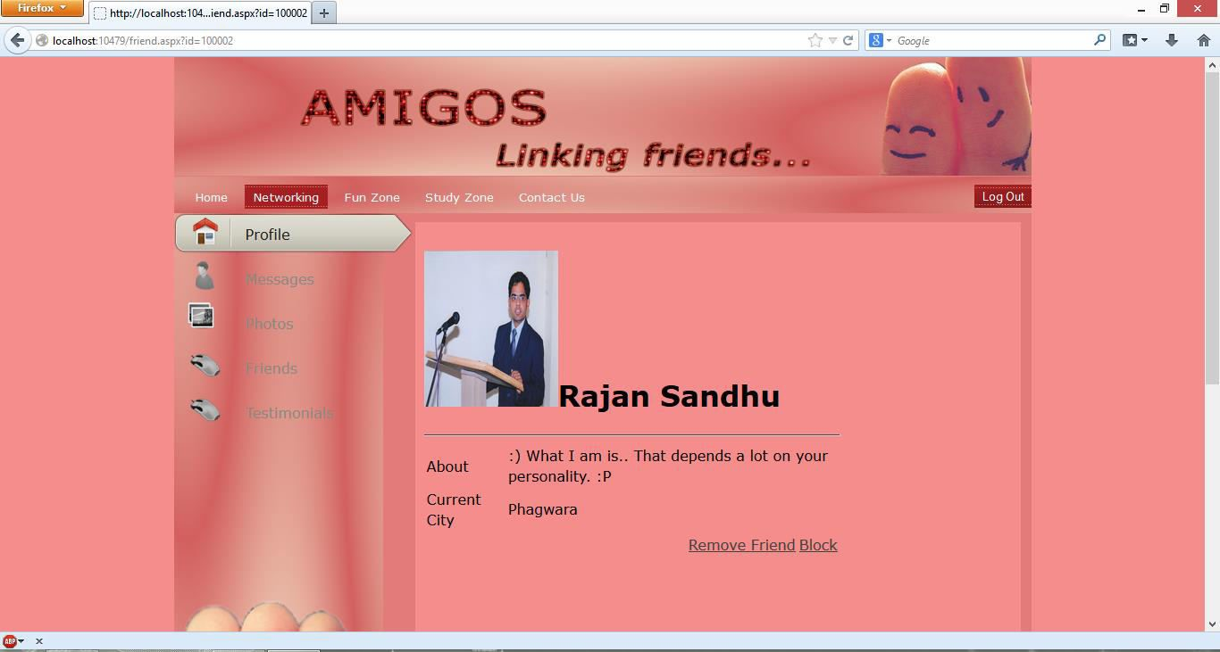

Figure 15.16: Friend’s Profile Page (Profile Tab)

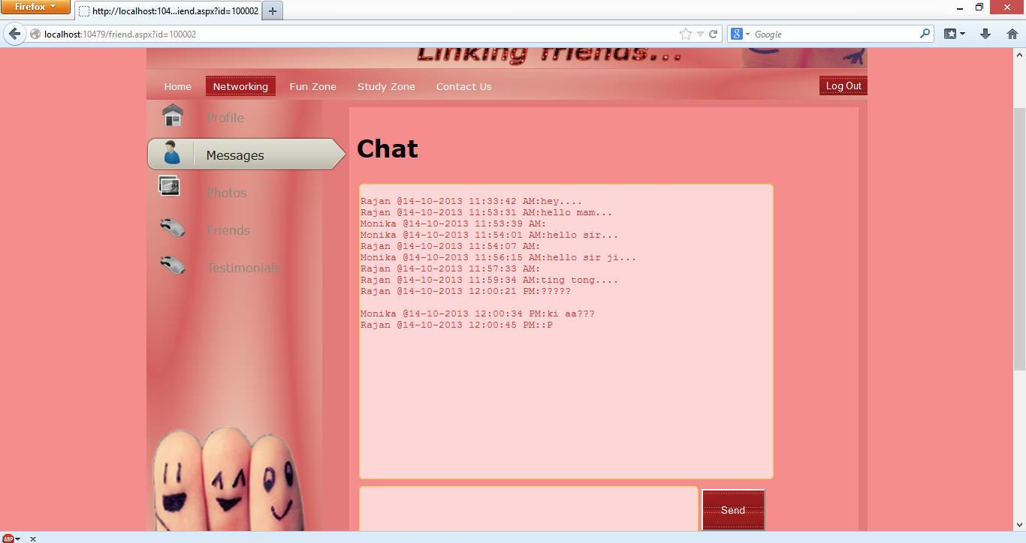

Figure 15.17: Friend’s Profile Page (Messages Tab)

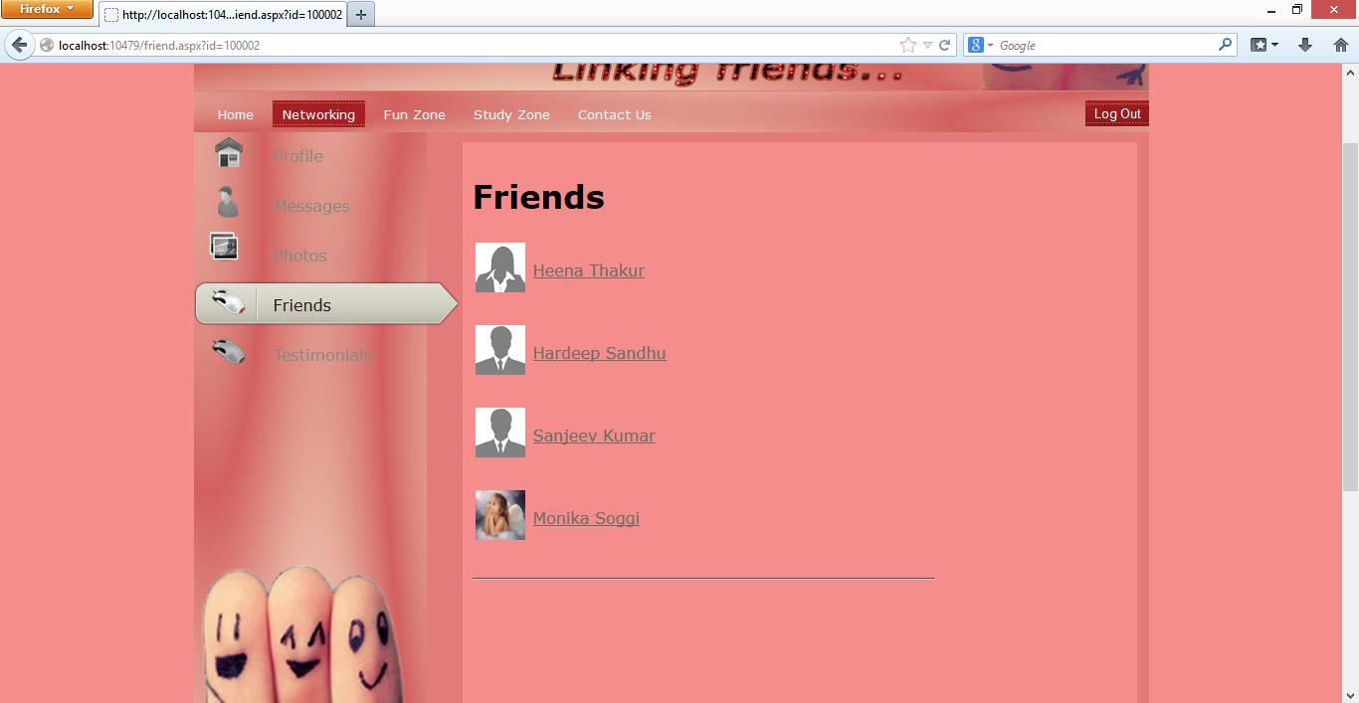

Figure 15.18: Friend’s Profile Page (Friend List Tab)

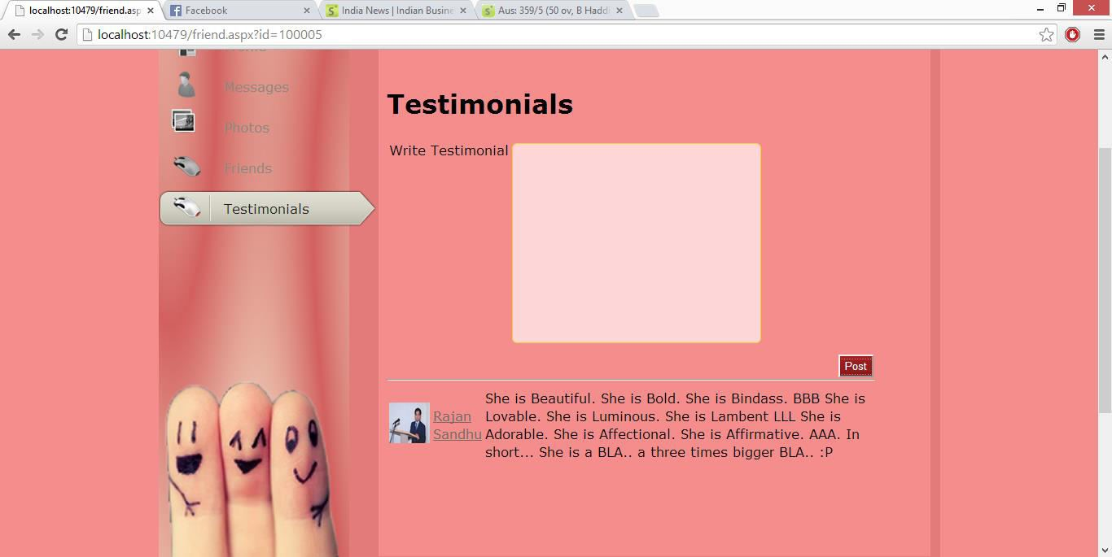

Figure 15.19: Friend’s Profile Page (Testimonial Tab)

Figure 15.20: Login Page

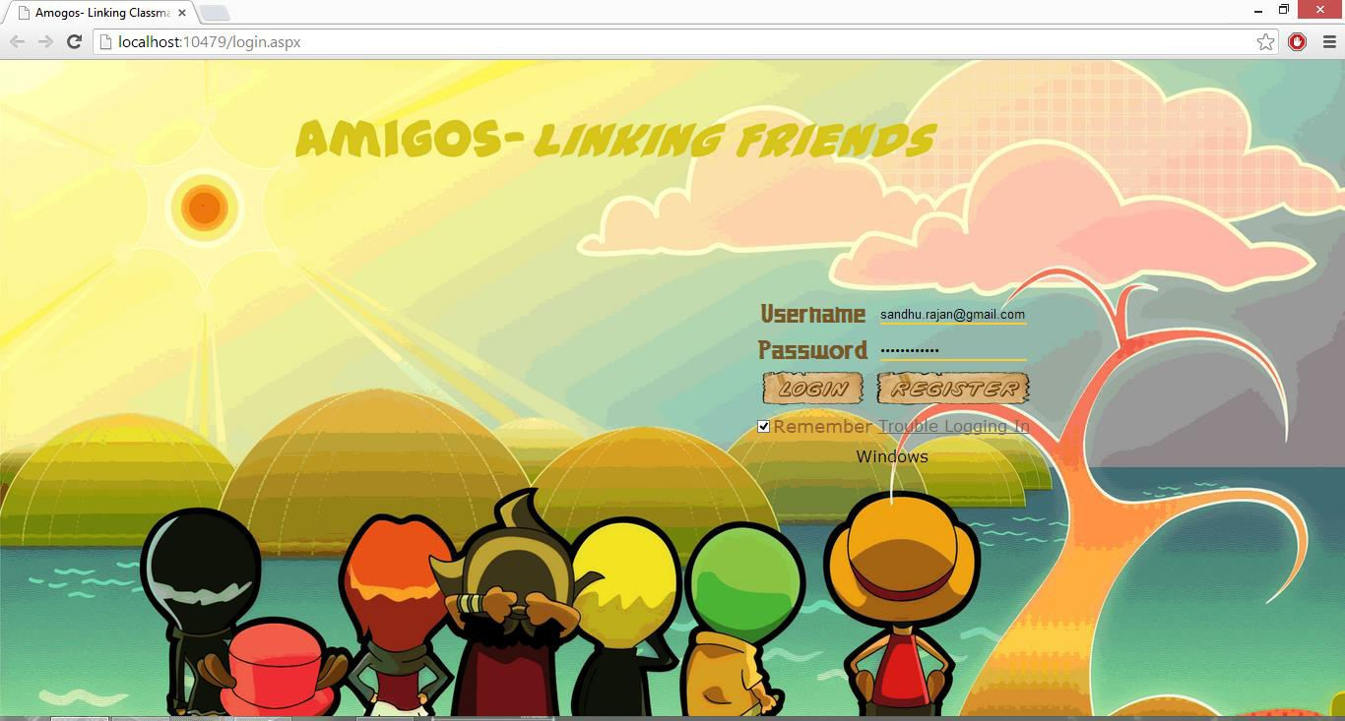

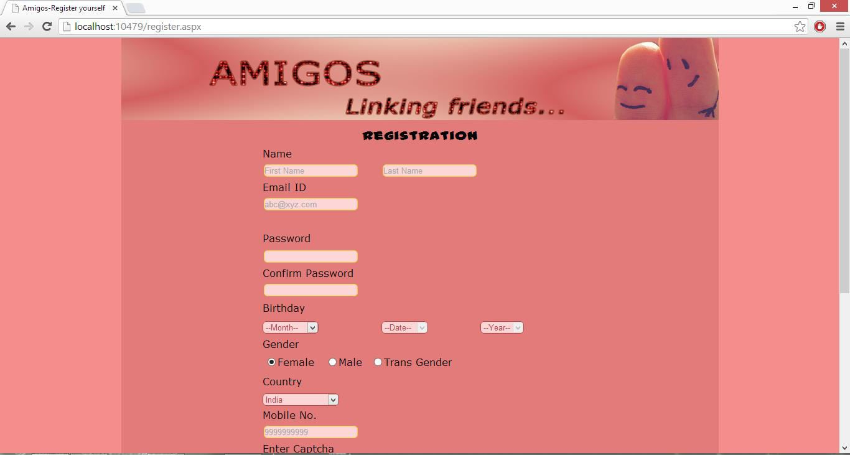

Figure 15.21: Registration Page

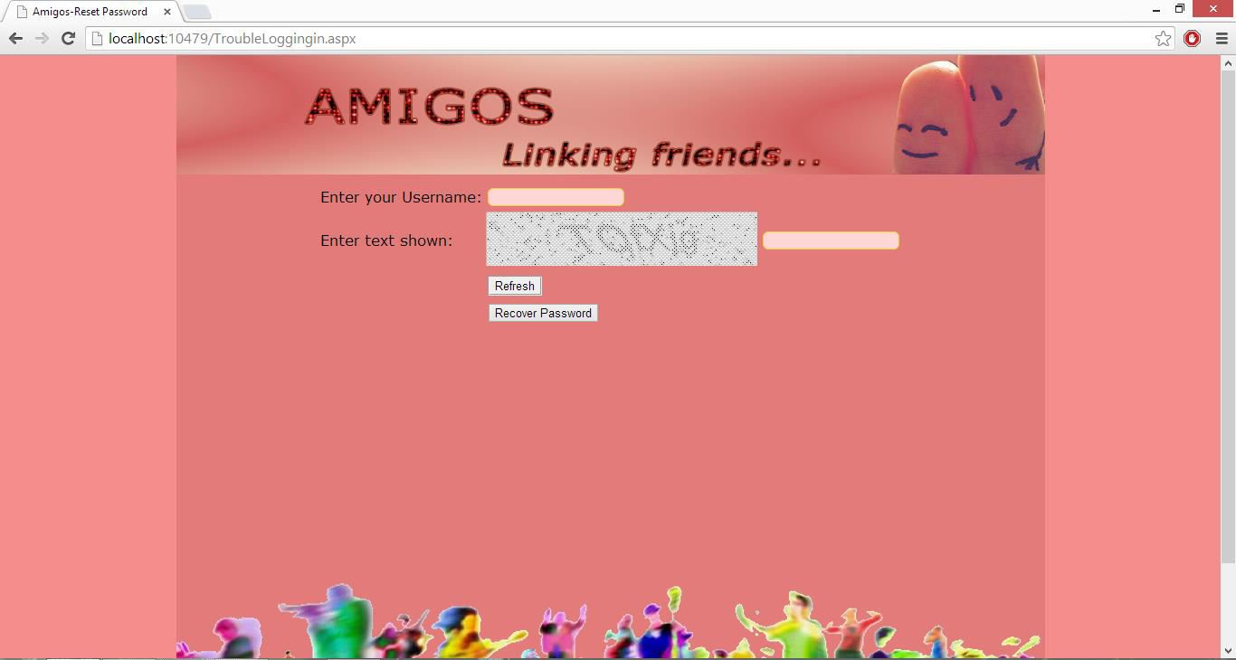

Figure 15.22: Password Reset Page

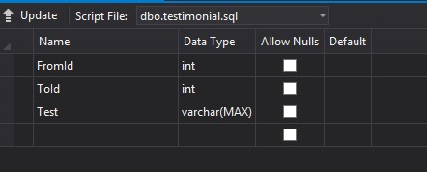

Figure 15.23: Database Table (Testimonial)

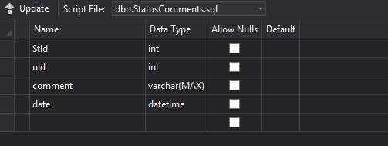

Figure 15.24: Database Table (StatusComments)

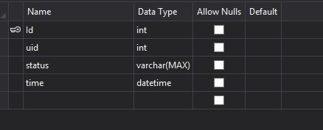

Figure 15.25: Database Table (Status)

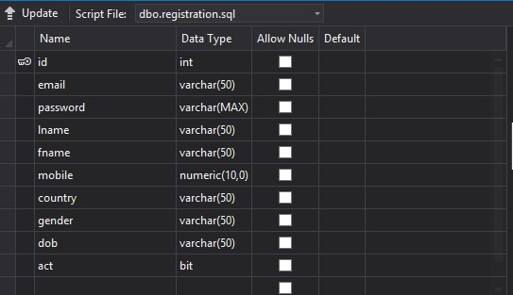

Figure 15.26: Database Table (Registration)

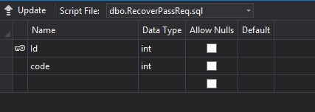

Figure 15.27: Database Table (RecoverPassReq)

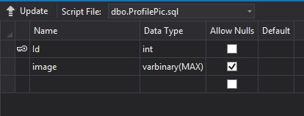

Figure 15.28: Database Table (ProfilePic)

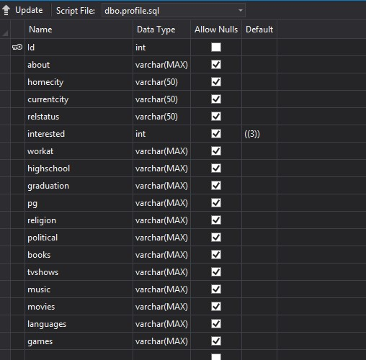

Figure 15.29: Database Table (Profile)

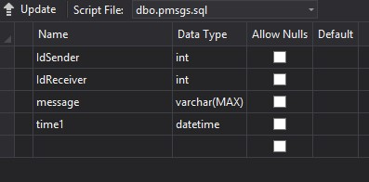

Figure 15.30: Database Table (PrivateMessages)

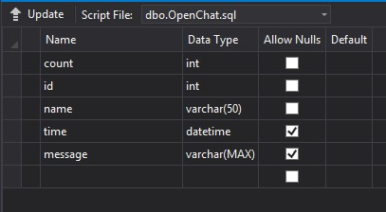

Figure 15.31: Database Table (Open Chat)

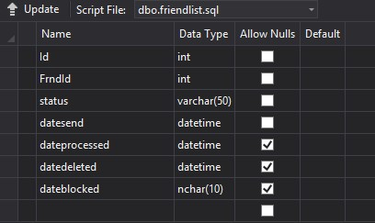

Figure 15.32: Database Table (FriendList)

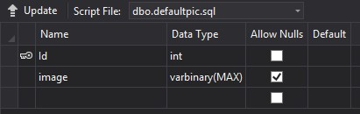

Figure 15.33: Database Table (Default Pic)

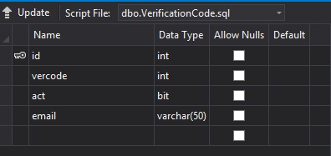

Figure 15.34: Database Table (VerificationCode)

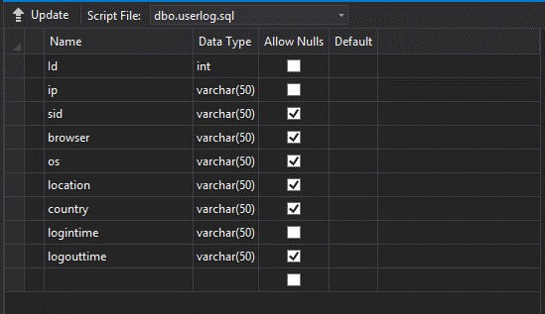

Figure 15.35: Database Table (userlog)

#### Conclusion

This report introduced the development of a new social networking titled Leechi which etymologically means Friends. Leechi is better than what Mark Zukerberg developed in the year 2004. Leechi aims at removing the present major shortcomings of Facebook which includes missing Captcha support at login, no testimonials writings provisions, no open chat facility, missing IT act guidelines for social networking and short-bit Hashing algorithm. The primary target is to eliminate those pitfalls of Facebook and include basic social networking functioning and later incorporate other Facebook features gradually. The various technical details of the project are also discussed which includes use of frontend and back-end tools and technologies, designing tools, data flow diagrams of the project and the various modules along with their current status of development in which the project will be carried out and the proposed time limit for each module.

The project has been developed by me under the guidance of Ms. Naina Mohan, a trainer and developer at DreamTech Labs.

#### Bibliography

1. Kognet Learning Solutions Inc. ASP.NET 4.0 in Simple Steps. Delhi:

DreamTechPress, 2013

1. Balagurusamy, E. Programming in C#. New Delhi: Tata McGraw-Hill, 2007
2. Albabari, Joseph and Alababri, Ben, C# 4.0 IN A NUTSHELL The Definitive reference.

Sebastopol: O’Reilly, January 2010

1. http://en.wikipedia.org/wiki/Facebook. Wikipedia, 10 August, 2013
2. http://stackoverflow.com/. Stackoverflow
3. http://youtube.com/
4. Mohan, Naina. Trainer and Developer, DreamTech Labs